**AWS Task-2**

**Task Description:**

Set up a VPC with an Internet gateway, create a public subnet with 256 IP addresses, a private subnet with 256 IP addresses, make a route table connecting the Internet gateway and the subnets, and launch a Linux EC2 instance by using the above VPC and public subnet.

**Create a demo-vpc :**

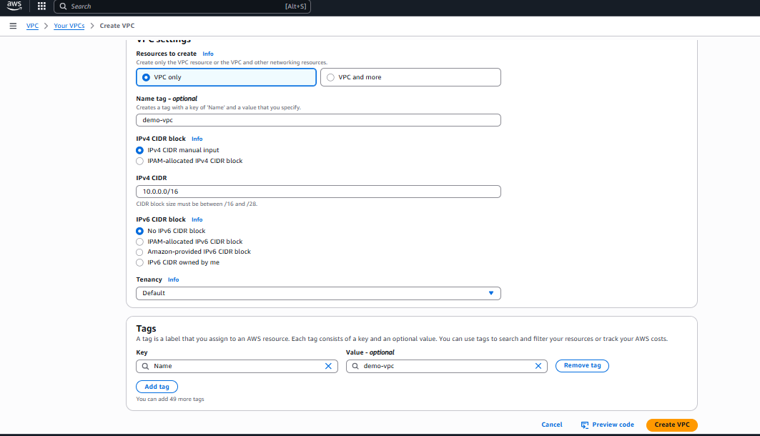

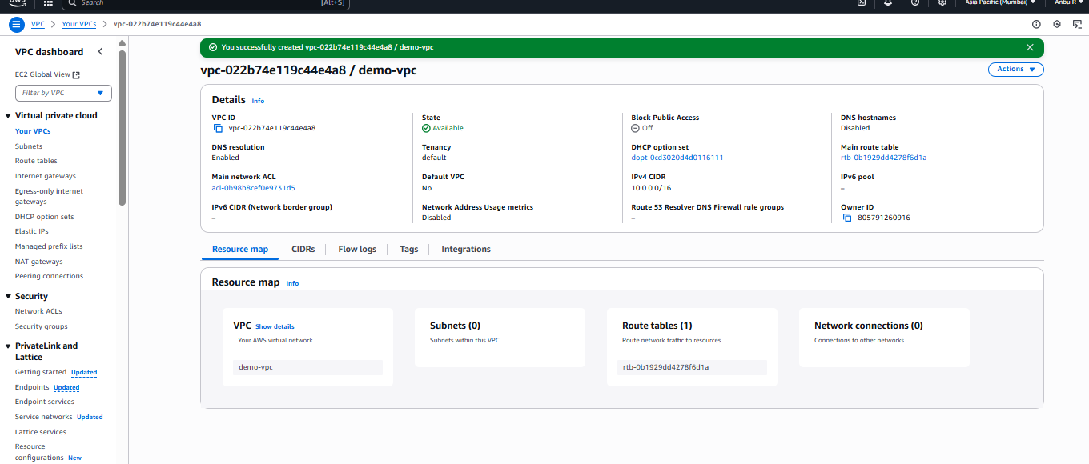  
**Create a subnet IP with 256 address:**

**Name: demo-subnet-1a : Public IP subnet range: 10.0.0.0/24**

**Name: demo-subnet-1b ; Private IP subnet range: 10.0.1.0/24**

**Name: demo-subnet-1c ; Private IP subnet range : 10.0.2.0/24**

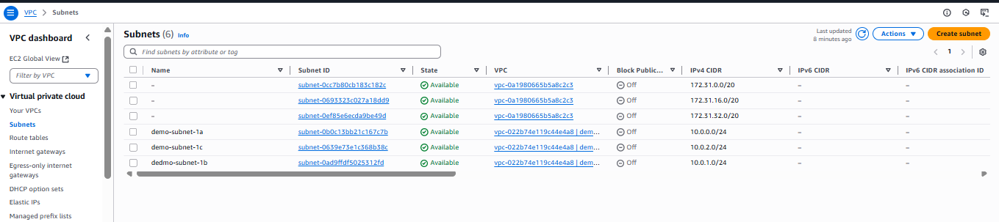

**Create route table :**

**Created route table and attached using explicit subnet association with the respective subnet to the private and public route table:**

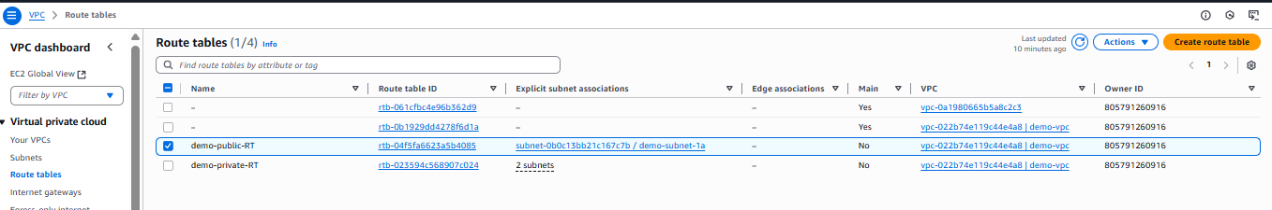

**Created internet gateway:**

**After creating internet gateway attach it to the VPC**

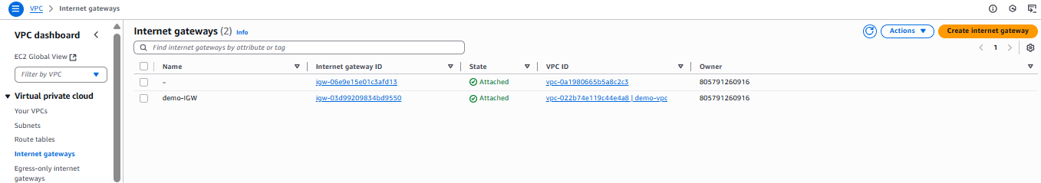

**Launch an EC2 instance using public subnet IP to connect to it:**

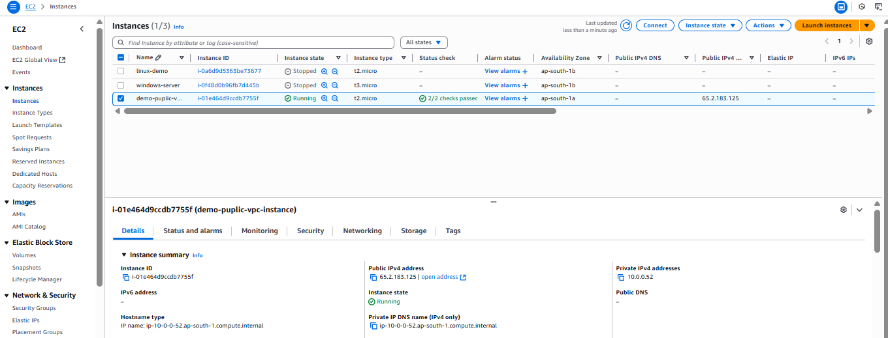

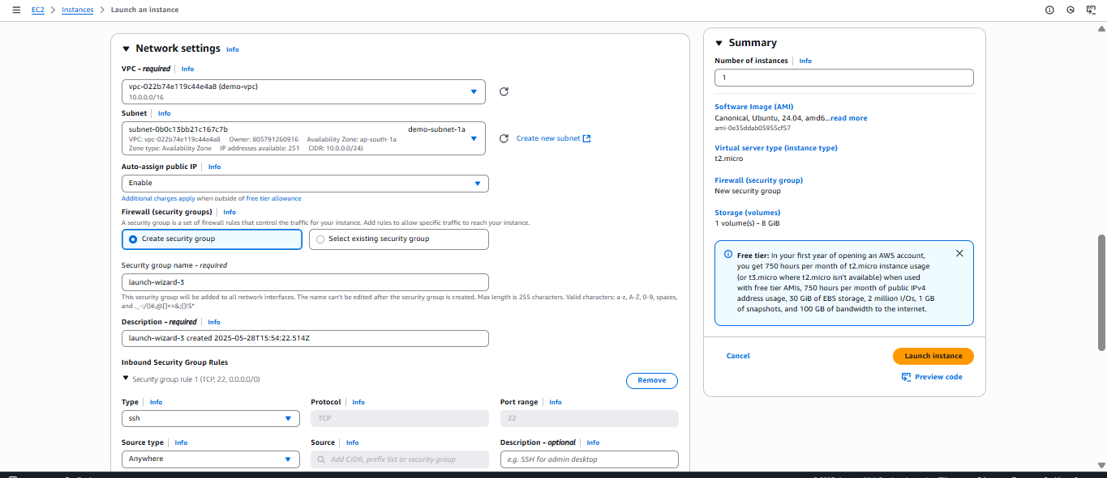

**After creating respective IGW , route table in public subnet IP range. We were able to connect to the ec2 instance launched in the public subnet through internet using public IP;**

